Actually, selective hunting does select

Marco Festa-Bianchet, Université de Sherbrooke
M.festa@usherbrooke.ca

Ram 642 was born in 2001. He immigrated to Sheep River where I tagged him in 2002. He had unusually rapid horn growth and would have likely grown very large horns had he survived to 7-8 years. He was, however, shot at 4 years of age because his horns fit the 4/5 curl definition, a rather exceptional feat for a four-year-old. For fast-growing rams, surviving through multiple hunting seasons is a challenge. The 4/5 curl limit means that rams with fast-growing horns get shot before they can pass on their genes, leaving rams with smaller horns to do the breeding. Small-horned rams must love it: their competitors are killed before the rut. Horn size is at least partly inheritable, so it should be no surprise that removing these high-quality rams sets up an artificial evolutionary response. This is not rocket science: if dairy farmers sent prize stud bulls to McDonald’s and let the losers sire calves, milk production will decline.

In Alberta, when bighorn rams are registered after harvest, only total length, base circumference and age are recorded . That is unfortunate, because annuli measurements would provide much useful information from each harvested ram. Annuli are measured in BC. In the BC Rockies, rams must be full-curl to be legal, and the faster the horn growth, the younger the age at harvest. Just compare horn growth between the ages of 1 and 4 years: for those shot at age 5 it averages about 55 cm. If they are shot at age 7, it’s 50 cm. If they are shot at 10 years or older, it’s about 42 cm, or 24% less than those shot at age 5. We see the same with Stone’s rams: those shot at age 7 average 50 cm of horn growth during their second and third year, more than twice as much as those shot aged 9 years and older. These are not small differences.

No surprise here: rams can only be shot if they fit the legal definition, and if their horns grow fast they’ll get there sooner. Very promising rams, that would develop large horns if they survived to say 9 or 10 years, get shot 4-5 years earlier. So what? Well, unfortunately, large horns lead to high breeding success in older rams but not in young rams.

Data on ram reproductive success exist from 3 populations, including two in Alberta: Sheep River and Ram Mountain. In all populations, we see the same pattern: the alpha ram will use his large horns and body size to defend an estrous ewe. He has about a 60% chance of siring her lamb. The other 40% is shared among subordinates, and horn size makes little difference to their mating success. Ram 642 would have done well had he survived to 7-8 years, but he was shot at age 4. Large horns do little to improve the reproductive success of a 4-year-old: he would still be subordinate to rams that had survived to be older and heavier because their horns did not meet the 4/5 definition when they were young.

Horn size is inheritable: genetics accounts for a bit more than a third of its variability. That leaves almost two-thirds to environment: weather, population density and food quality. Take a young ram from Cadomin and put it on Ram Mountain, it will grow smaller horns than if you left it at Cadomin (believe me, I’ve done it). But take a young ram with a large-horned father and a young ram with a small-horned father in the same population at the same time, and the one with the large-horned father will grow larger horns. The one with the small-horned father will possibly die of old age as it will never become legal while the one with a large-horned father could be like ram 642 and get shot at 4 years. Which one will sire more lambs? The data are clear: under 4/5-curl restrictions, rams with small-horned ancestors and small-horned descendants live longer and sire more lambs than those with large-horned ancestors and (potentially) large-horned descendants. We can say this because we know the fathers and mothers of our study sheep going back 7 generations. Dave Coltman published these results 12 years ago, showing artificial evolution of small horn size on Ram Mountain.

Unfortunately, Dave’s paper was seized upon by anti-hunting groups and some media to say that all trophy hunting is bad. The initial reaction from many was to say that this decline in horn size only happened at Ram Mountain, a small isolated population where ‘legal’ rams had about a 40% chance of getting shot and that it could not be happening elsewhere..

We now know that it is not true having looked at over three decades of trophy ram registrations. In Alberta, for a given age the horns of harvested rams are now about 3 cm (or 3.5%) shorter than they were about 30 years ago. Note that I say of ‘harvested rams’. We don’t know what is happening to the entire population because we can only look at rams shot by hunters. Small-horned rams cannot be shot, so they do not show up in the harvested sample. That was very clear at Ram Mountain where over 17 years, the average horn length of 5-year-olds declined by almost 14 cm, but if we only looked at rams shot by hunters, the decline was less than 8 cm. This is an important issue: using harvested rams as your sample will likely underestimate any declines in horn size.

Two other long-term changes are evident from the Alberta bighorn harvest: fewer young rams are legal and the harvest has declined despite a stable population. The proportion of rams aged 4 and 5 years in the harvest was about 25-30% three decades ago: it is now less than 10%. Most rams aged 4 and 5 years now do not reach 4/5-curl, because their horn growth has slowed. I find it hard to believe that people can seriously say that the ram harvest has not changed. The reality is that the harvest by Alberta residents was about 200 in 1980-1995 but averaged about 140 in recent years, a 35% drop. The harvest in 2014 was the lowest since 1974, when half as many hunters bought trophy sheep tags. Given that the overall sheep population has not declined, one may wonder why it is producing fewer legal rams. Hunter success has declined by about 14%: for every 2000 licenses in 1974, Alberta residents shot 124 rams. For 2000 licenses in 2010, they only got 107. Success rate is now about 5%. I wonder how many of the 95% of unsuccessful hunters never see a legal ram.

The decline in ram horn length in Alberta over the past 3 decades mirrors what we see in other sheep populations with a heavy harvest rate. Horn length of ‘California’ bighorn sheep in BC, hunted under a ¾-curl limit, has declined by about 4% over 27 years. The horn length of BC Rocky Mountain bighorn rams, hunted under a full-curl definition and an unlimited entry system, however, has NOT declined over the same period. Think about that. Rams in Alberta have shrunk, rams just across the divide in BC have not: why? One difference between the two provinces is the more permissive definition of legal ram used in Alberta. We find the same in Stone’s sheep in northern BC. There, hunting pressure is much higher in the Peace region than in the Skeena region, because of easier access. Over the past 30 years, early horn growth in the Peace has decreased by about 12% but in the Skeena it has not changed. Once again, high hunting pressure and a high harvest of trophy rams led to a decline but where harvest was low there was no detectable effect.

So, ram horns are getting smaller where they are heavily hunted (Alberta, interior BC, the Peace) and not where harvests are not as intense (BC Rockies, the Skeena). What are the possible reasons? One could be deteriorating habitat, because of high population density, but that is hard to believe since density in most sheep ranges in Alberta has been stable for about 30 years. I was somewhat alarmed to hear Mark Boyce’s suggestion that to solve the problem ESRD should increase non-trophy permits and lower population density by 20% to stimulate ram horn growth. I am not sure that killing about 1400 ewes is a good idea, and I wonder what those that blame predators for short-horned rams think of that proposal.

True, the Ram Mountain research showed that as population density increased, the size of ram horns declined. That decline in horn size happened as the number of ewes tripled and population size more than doubled. We are not seeing those massive population increases anywhere in Alberta, and certainly not over the entire province. The decrease in non-trophy permits has not led to any noticeable population increase. Biologists may have reduced the number of permits because of concerns about vulnerable populations and increasing predation – for example, both the Sheep River and Ram Mountain populations (even mountain goats at Caw Ridge!) have been heavily impacted by specialist cougars. Perhaps cougars only prey on bighorns in my study areas, but as ewe permits were cut back, the population overall remained more or less stable.

Perhaps a stable population is a sign of ‘too many sheep’ anyway? That seems unlikely considering the reasonable lamb crops reported by most recent surveys, although local declines have been noted. To learn more about this possibility, let’s compare rams shot near and far from National Parks and protected areas. Early in the season, once age is accounted for, rams shot in WMUs far from protected areas have horns only about 1 cm shorter than those of rams shot in WMUs near the parks. As the season advances, horn length of rams shot far from the parks stays the same. Near the National Parks, however, for the same age, rams shot later in the season have longer horns. Not a huge difference, just over 1 cm, but why should a 6-year-old shot in early September have shorter horns than a 6-year-old shot in late October, given that horn growth has stopped by then? And why the change only near protected areas? As most hunters know, rams start looking for ewes by late October, and some will come out of National Parks. The data therefore hint that for a given age, rams in National Parks have longer horns than rams in the hunted provincial areas. That casts some doubt on the “too many sheep” hypothesis, as there is no ewe hunting in protected areas. Also, note that there are currently no ewe harvests in the BC Rockies or in the Skeena - both places where ram horns did not shrink.

There are still a few very large, older rams in protected areas: three rams from Alberta made it to the top of the Boone & Crockett book in the last few years. All three spent most of their lives in areas with no hunting and died at 12 years or older. For further proof that there has been a decline in available trophy rams in Alberta, just compare the size of rams shot by residents and guided nonresident. There is no difference. Apparently, it costs nonresident hunters about $30K for a sheep hunt in Alberta. About half are successful, and go home with a ram that averages less than 33”. In northern BC, however, as one may expect guided hunters take larger Stone’s rams than residents, evidence that large rams are still available.

A recent Wildlife Monograph claimed that one could use the B&C records to monitor horn size of bighorn sheep over decades. There was no evidence that the size of record bighorn rams in the B&C has declined over the last 30-40 years, it may even have increased a bit. That should not surprise anyone, given that you cannot get into the B&C unless you score over a threshold: it’s like using the 100-m dash at the Olympics to monitor the average speed of humans on the planet, or assessing a country’s GDP by only looking at the income of billionaires. This monograph also combined data from multiple jurisdictions with different harvest strategies. Alberta is the only jurisdiction that offers unlimited hunting opportunities for rams with a 4/5 curl limitation. Harvest pressure on trophy rams is probably higher in Alberta than any other jurisdiction.

I was puzzled by reading in a piece in the Alberta Outdoorsman written by TJ Schwanky that “The theory that trophy hunting was causing genetic harm to Alberta bighorn was shot full of holes by the scientific community”. I am not sure where Mr. Schwanky is getting his information and I wonder what he’s referring to. The recent Wildlife Monograph I mention above? Interesting sampling technique but perhaps a bit biased? Maybe he reads the Proceedings of the National Academy of Science, where a recent paper that contained NO data on horns simulated a ‘let’s pretend’ selective hunt of rams heavier than 100 kg (an interesting concept) and claimed that despite selection, average weight did not decrease? A follow-up publication recently demonstrated that Trail could never have picked up evidence of evolution because it assumed no heritability of adult mass. It is like taking the height of men and correlating it with that of their newborn infants: that correlation will likely be weak, yet tall men tend to have children that are tall as adults. Similarly, large-horned bighorn rams have offspring that are large-horned as adults, but father mass has almost no influence on mass at weaning. In a more recent piece, Schwanky claims that Val Geist has ‘spoken out’ against this theory. That is an interesting claim, because Dr. Geist has told me the opposite, in writing.

More seriously, a critique of Dave Coltman’s 2003 paper claimed that the paper may have confused an environmental effect (due for instance to deteriorating habitat or increasing sheep density) with a genetic effect. We have now reanalyzed the data taking that critique into account. The result is nearly the same: the genetic value of horn length declined from 1975 to 1995. The decline then stopped, coincident with a change in hunting regulations from 4/5 curl to full-curl for the Ram Mountain population. We now have experimental evidence that the decline in horn size can be stopped, if not reversed, by changes in hunting regulations.

So, a ram with large horns will sire many lambs if it could survive to 8 years, but under the 4/5-curl regulation it may get shot at 4 years, as happened to ram 642. We have a decline in horn size over time, a decline in hunter success rate, a decline in the proportion of young rams in the harvest, and evidence that rams in protected areas are larger than in hunted areas. Rams in BC, hunted under full curl, have not shrunk. In most of the US and Mexico bighorns are hunted on a draw and hunters typically take rams aged 8-10 years. If one is happy with a 5% success rate, diminishing harvests and shrinking rams, push for the status quo. If you think wildlife management decisions should be based on science, I’ve listed a few lines of evidence suggesting that a change is warranted.

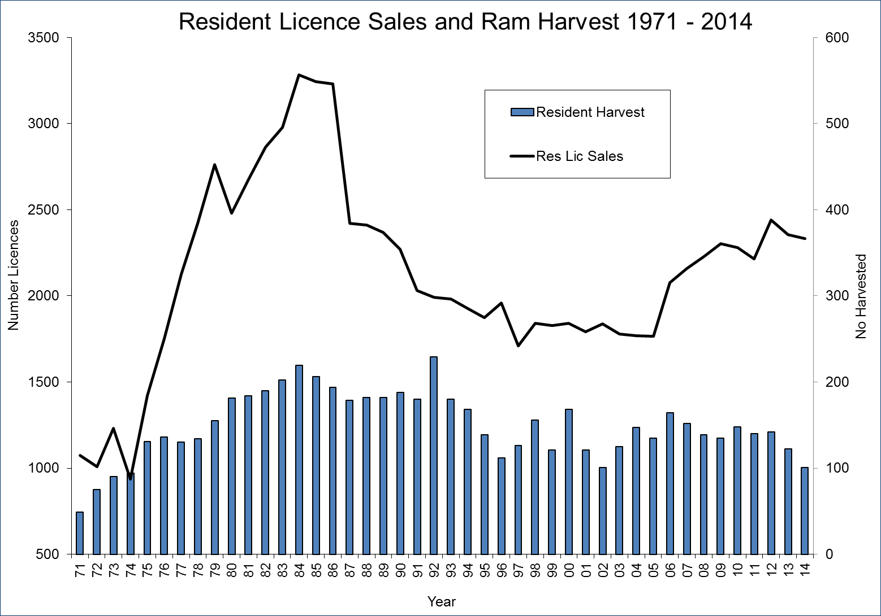

Ram 642, shot at Sheep River as a barely-legal 4-year-old.

